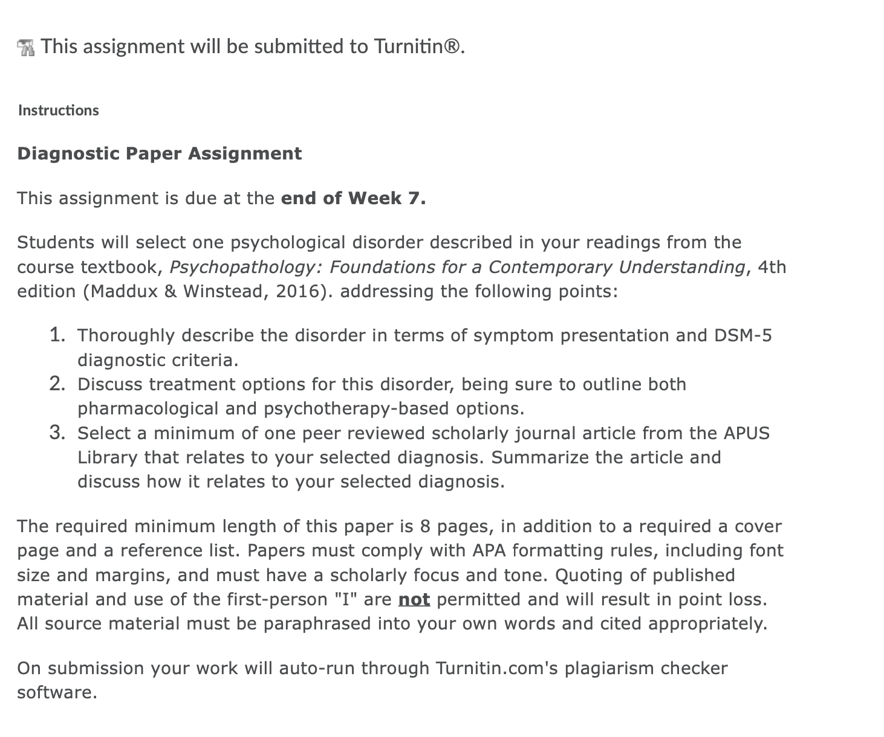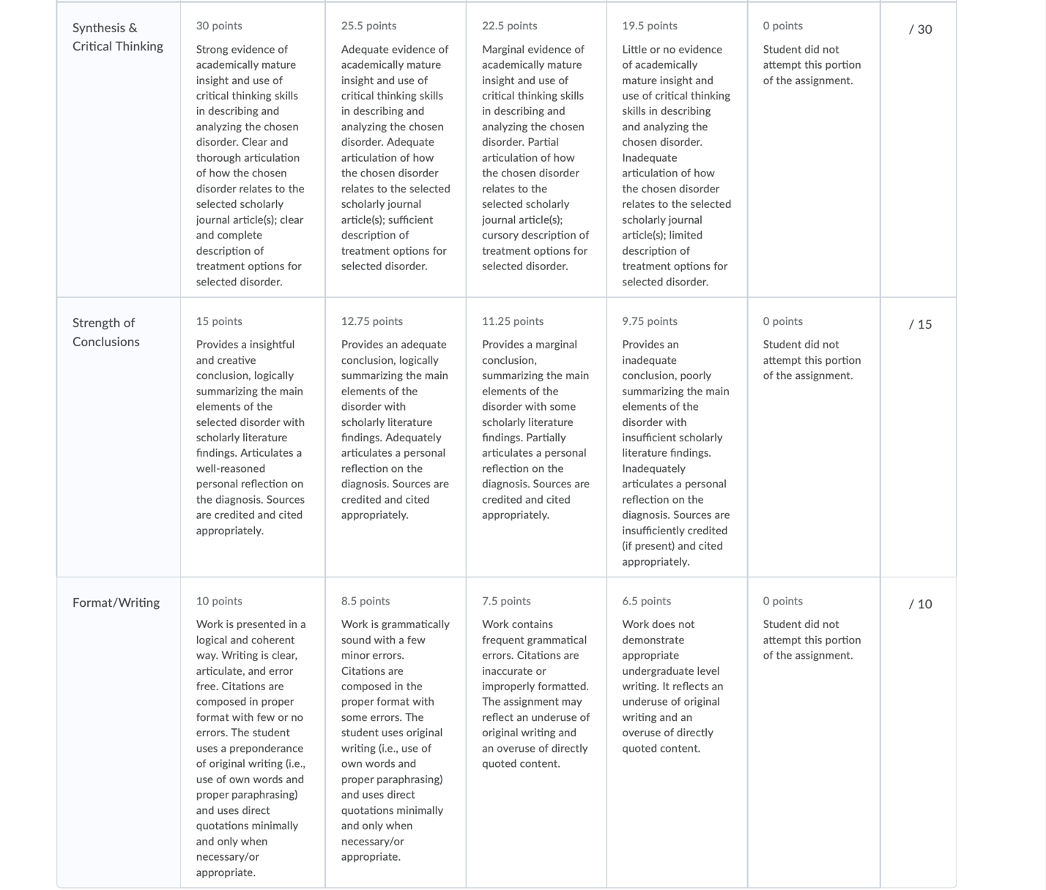
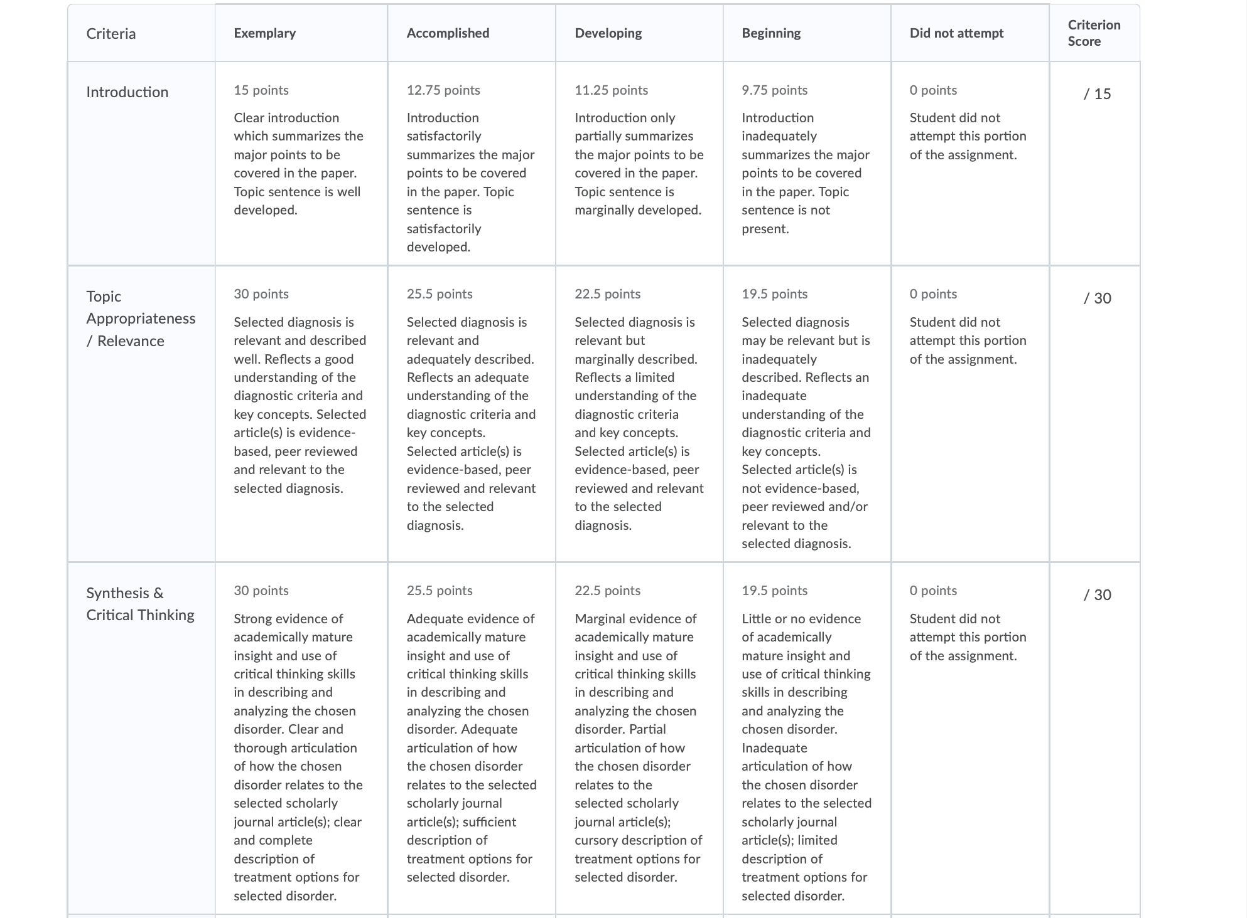

Article citation:
Kovács, L. N., Takacs, Z. K., Tóth, Z., Simon, E., Schmelowszky, Á., & Kökönyei, G. (2020). Rumination in major depressive and bipolar disorder – a meta-analysis. Journal of Affective Disorders, 276, 1131–1141. https://doi.org/10.1016/j.jad.2020.07.131

Book citation:
Maddux, J. E., & Winstead, B. A. (Eds.). (2015). Psychopathology : Foundations for a contemporary understanding. ProQuest Ebook Central https://ebookcentral.proquest.com

